Talk - User's Guide
==============

Advanced Electronic Systems
106, 8th Main Road, Near 18th cross
Malleshwaram West, Bangalore - 5600 055.
Tel : 3341004, 3361843

- Introduction

Talk is an RS-232C Serial Communication program for Microsoft Windows 98, Windows ME, Windows NT, Windows 2000, and Windows XP Operating Systems. This serial communication program is meant to be used with the Advanced Electronic Systems (ALS) Trainer Kits like 8031, 8085, 8086 etc.

1.10 System Requirements

Hardware: an Intel x86 based Computer
Software: Microsoft Window 98, Windows ME, Windows NT, Windows 2000, or Windows XP.
Hard-Disk Space: ~10MB
Memory: 64MB

1.20 How to Install?

- If you are Installing on Windows NT/2000/XP, Login as an Administrator else go to step 2.
- Insert the Talk CD in to the CDROM drive
- Using Windows Explorer, Locate the file SetupTalk.exe on the CD.
- Double-Click on the SetupTalk.exe file
- Follow the on-screen instructions.
- If the Setup program prompts for a REBOOT of the machine, you must reboot the system in order to use the Talk program.

1.30 How to Uninstall?

Method 1: Using Add/Remove from the Control Panel

Method 2: Click on Start→Programs→Talk→Uninstall

2.0 How to connect the ALS Trainer Kit to your Computer?

- Locate a free COM port (COM1, COM2, etc) connector ( usually it is located at the back of the computer)
- Connect one end of the Serial Cable (shipped with the Kit) to the identified PC COM port
- Connect the other end of the Serial Cable to the Trainer Kit.
- Connect the Trainer Kit Power supply cable (Refer to your ALS Trainer Kit Manual)
- Set the Baud, Data bits, Serial Mode etc for the Trainer Kit as given in the Kit manual ( Refer to the ALS Kit Manual ).
- Run the Talk program on your computer, Start→Programs→Talk→Talk (see Section 2.10).
- From Talk’s Options→Settings Menu, Set the Baud, Data bits, etc to the same parameters as that of Trainer Kit ( See Section 2.20).
- Select the type of Trainer Kit (8085, 8031/51, 8086) from Options→Target Board Menu ( See Section 2.30).
- Connect to the COM port using Talk’s Options→Connect menu ( See Section 2.40).
- Switch on the Power Supply for the Trainer Kit.
- Put the Trainer Kit into Serial Mode (Refer to your ALS Trainer Kit Manual)
- If you can see the Sign-On message of the Trainer Kit on the Talk’s terminal window, then you have successfully established the connection.
- Once the connection is established successfully, you are ready to use the Talk program with your ALS Trainer Kit.
- Whenever you type a command for the Trainer Kit, make sure that the Cursor is in the Talk’s terminal window.
2.10 How to Run the Talk Program?

As part of the Talk Program’s Installation, a shortcut is placed on the Start Menu Program. Click on the Start→Programs→Talk→Talk.

When the Talk program is launched, a window is displayed similar to the one shown below:
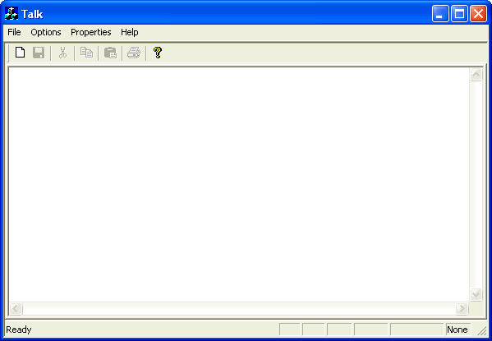
Menu Bar
Tool Bar
Terminal Window
Status Window
Vertical Scroll Bar
CAP Lock
NUM Lock
SCRL Lock
COM Port
COM Settings
Trainer Kit Type
Horizontal Scroll Bar

2.11 How to Close the Talk Program?

Once you have completed working with the Talk Program, you can close it by clicking on the File→Exit menu.

  - Configuring COM port Settings

From the ‘Options ‘menu select ‘Settings’ (Click on Options→Settings).

Select the desired parameters like COM port, Baud rate, etc and then press OK button.

  - Selecting the Trainer Kit

The Talk program can be used with the ALS 8085, 8031/51 and 8086 Trainer Kits. So, it is important to select the type of Trainer Kit for which you are establishing connection with the Talk program.

Click on Options→Target Board.
Select the desired Kit and Press OK button.

2.40 Connecting/Disconnecting

To connect the Talk program to the Selected PC COM port, Click on Options→Connect.

To disconnect the Talk program from the PC COM port, Click on Options→Disconnect. Once it is disconnected, the Talk program will not send/receive
anything from the Trainer Kit.

2.50 Downloading an Intel HEX file to the Trainer Kit

Before downloading/Uploading an Intel Hex file, make sure that you have selected the correct Trainer Kit (Options→Target Board menu) for which you have established the connection (8085, 8031/51 or 8086). Also make sure that you have a valid Intel Hex file.

To download, Click on File→Download Intel Hex file menu. The Talk program will pop-up an “Open File“ Dialog Box. Using this “Open File” Dialog Box, you can navigate to any drive/folder to select your Intel Hex File. Select the desired file and click on “Open”. Once the File Download operation is completed, the Talk program will return to the terminal window.

2.50 Uploading to an Intel HEX file from the Trainer Kit

To upload, Click on File→Upload Intel Hex file menu. The Talk program will pop-up a file “Save As” Dialog Box. You can type a file name or select the existing file. If the file doesn’t exist, it will be created, if the file exists, you are prompted for over-writing on the existing file.

Next, the program prompts for Starting memory address and Ending memory address. Enter the Start address and End address in hexadecimal and click the OK button.

Once the File Upload operation is completed, the Talk program will return to the terminal window.

